Attachment:
The Form of Hainan Halcyon Rubber Tech. Co., Ltd. TSR 20 Futures Product Marking Design
Registrant | Factory Name | Product Marking Design
Hainan Halcyon Rubber Tech. Co., Ltd. | Xishuangbanna Halcyon Rubber Tech. Jinghong Rubber Factory  (BX) | 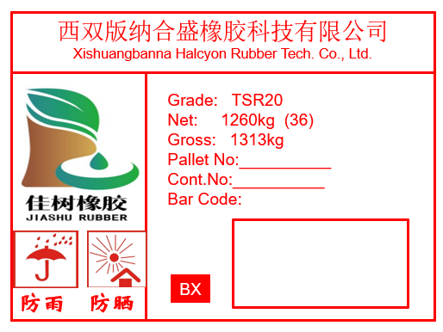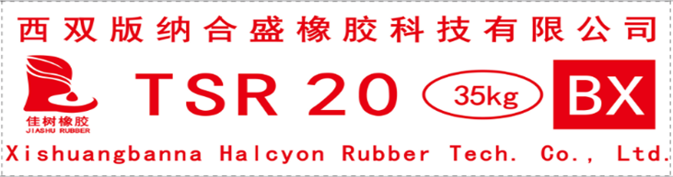 | Old design
 | Yunnan Halcyon Rubber Tech. Jinghong Rubber Factory  (BX) | 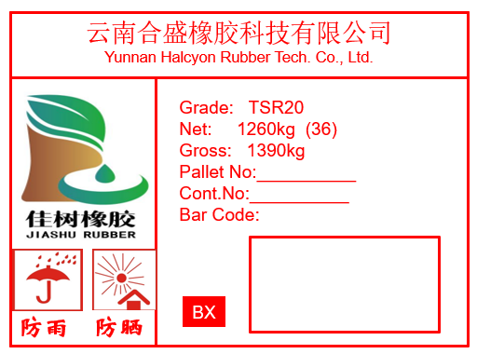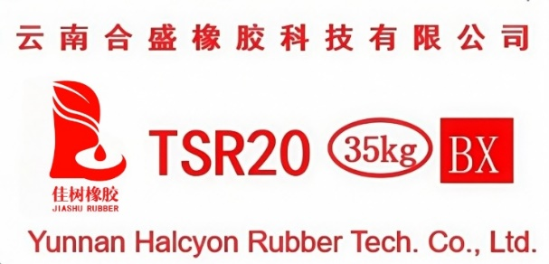 | New design

