Shanghai International Energy Exchange Co., Ltd. (INE)
Market Data Platform, SMDP2.0
Network Access Guide

Version: 1.0
Released on: November 13, 2018

- Records of Revision, Verification and Review
Record of Revision
Version No. | Revised on | Summary
0.1 | September 5,2018 | Drafted by Zhou Hao, Huan Lingfeng
1.0 | November 13,2018 | Revised and compiled into a formal file according to revision suggestions by Zhou Hao

Record of Verification
Verified by | Department (Unit) | Verified on
Zou Wenjun | SFIT | November 13,2018

Record of Review
Reviewed by | Department (Unit) | Reviewed on
Tao Hongbao | SFIT | November 13,2018

This document is made and maintained by: Shanghai Futures Information Technology Co., Ltd.

Contents
1. Overview 4
2. Platform Introduction 5
2.1. Services 5
2.2. Deployment Mode 6
3. Technical Requirements for Members 7
4. Security Requirements 8
5. Reference Model for Member Access 9
5.1. Access Reference Model I (Channel Separation) 10
5.1.1. Configuration Example I (SSM Mode) 11
5.1.2. Configuration Example II (ASM Mode) 12
5.2. Access Reference Model II (Channel Sharing) 13
5.2.1. Configuration Example I (SSM Mode) 14
5.2.2. Configuration Example II (ASM Mode) 15
6. Application Procedure and Processing 16
6.1. Application Procedure 16
6.2. Application Processing 17
7. Troubleshooting Guide 18
7.1. Basic Policy 18
7.2. Basic Approaches 18
8. Member Application Form 20

Overview
For the purpose of more efficiently sending the market data, Shanghai International Energy Exchange Co., Ltd. (INE) has launched the INE Market Data Platform (SMDP2.0). The new platform adopts technical methods such as data encoding compression and multicast transmission to further improve the service quality of data feeding.
This Guide introduces the INE Market Data Platform (SMDP2.0), and specifies its technical requirements, suggested network models, application procedure, etc. To connect to the Platform, all data information vendors are advised to follow this Guide.

Platform Introduction
SMDP2.0 is built on an architecture as follows:
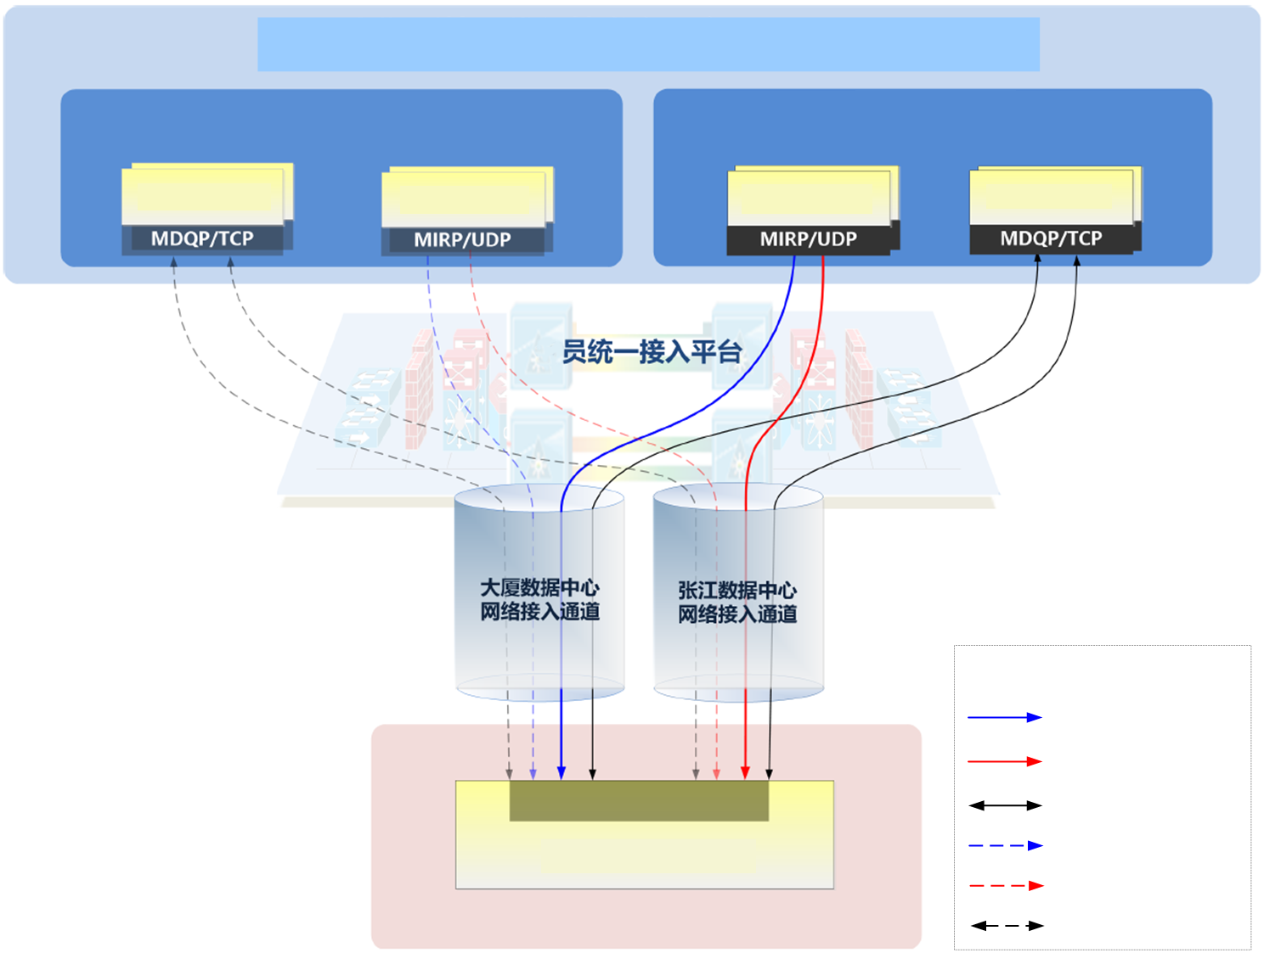
INE Market Data Platform (SMDP2.0)
Market Data Query
Secondary Center
Primary Center
Market Data Incremental
Market Data Incremental
Market Data Query
INE
Membership Access Platform
PD-DC - Network Access Channel
ZJ-DC - Network Access Channel
Users’ Market Data Receipt Platform
Member-end
Legend
Primary Center MIRP Channel A
Primary Center MIRP Channel B
Primary Center MDQP
Secondary Center MIRP Channel A
Secondary Center MIRP Channel B
Secondary Center MDQP
Figure 1 Architecture of INE Market Data Platform (SMDP2.0)

Services
The Platform provides market data query service in TCP and incremental feed service in UDP. For details, please refer to the <API Specification for SHFE Market Data Platform, SMDP2.0>.
- Market Data Query It allows users to log in/out, query topic snapshots and request the missed topic incremental market data. This function applies MDQP (Market Data Query Protocol) to interact with users. MDQP is built on TCP.
- Market Data Incremental: It sends the topic incremental to its subscribers in real time. This function applies MIRP (Market data Incremental Refresh Protocol) to inform users in a multicast manner. MIRP is built on UDP.

Deployment Mode
- SMDP2.0 is deployed in "three centers in two cities", including Shanghai Futures Building Data Center, Zhangjiang Data Center, and Beijing Offsite Disaster Recovery Data Center. SMDP2.0 runs under primary-secondary mode among the data centers.
- Each center is equipped with multiple front-end servers engaged in market data query and market data incremental services.
- Both market data incremental services and market data query services are provided by Primary Center only, and Secondary Center is not enabled (shown by dotted lines in the figure) for the time being.
- For market data query service, users may connect to the front-end servers in Primary Center, and request market data snapshots or missed incremental market data as needed via TCP.
- For market data incremental service, Primary Center provides two channels (Channel A and Channel B) for UDP-based multicast. The two channels push the same content. PD-DC network access channel pushes market data on channel A, while ZJ-DC network access channel pushes market data on channel B. Users are given access to both channels, and may choose any one for receipt as needed.

Technical Requirements for Members
Item | Requirement | Remarks
Communication Line | Line types¹: leased MSTP lines directly connected to INE, and LAN lines in Shanghai Futures Building. | For non-direct connect to INE, multicast market data transmission is not supported.
 | Access method: Dual-line direct connect to SHFE (1 line to PD-DC, 1 line to ZJ-DC).
Network Devices | Layer 3:  - PIM-SSM;  - IGMP v3. | It is recommended to use PIM-SSM + IGMP v3 for multicast2.  Alternatively, ASM mode is applicable as well:  1) Apply PIM Sparse Mode + IGMP v2;  2) Configure static RP towards the Exchange.
Layer 2:
IGMP Snooping.
Host/ Application | IGMP v3.
Remark 1: For information on receiving SMPD2.0 by the hosted access members, please refer to the access manuals released by hosting rooms.
Remark2: Compared with ASM mode, SSM mode does not require RP related configuration; By running SSM mode, it can directly construct a shortest-paths tree (SPT), which is more efficient.

Security Requirements
To ensure the security and reliability of trading networks, members are required to isolate their transaction networks and systems from non-transaction ones such as the Internet and office intranets, and follow the security control policy as below:
 | Market Data Query Front-end |  | Market Data Incremental Front-end
Data Center | Network Segment | Port | Network Segment | Port
PD-DC | 192.168.11.0/24 | TCP 33022 | 192.168.32.0/24  192.168.64.0/24 | UDP port; visit INE website for details
ZJ-DC | 192.168.12.0/24 |  | 192.168.48.0/24  192.168.80.0/24
Remarks: In case of changes to parameters, the latest release on INE website shall prevail.

Reference Model for Member Access
SMDP2.0 applies UDP-based multicast to send market data. Therefore, members’ network systems should be able to support multicast. For the purpose of helping members to better understand the network deployment requirements of the Platform, this chapter provides examples on how to plan a multicast network. Data information vendors may also refer to the following configuration examples for access.
The configuration examples in this chapter are for illustration and reference only. Members should adapt the configuration for their own environment. Cisco 3825 routers (IOS version c3825-adventerprisek9-mz.150-1.M2.bin) are used in examples.

Access Reference Model I (Channel Separation)
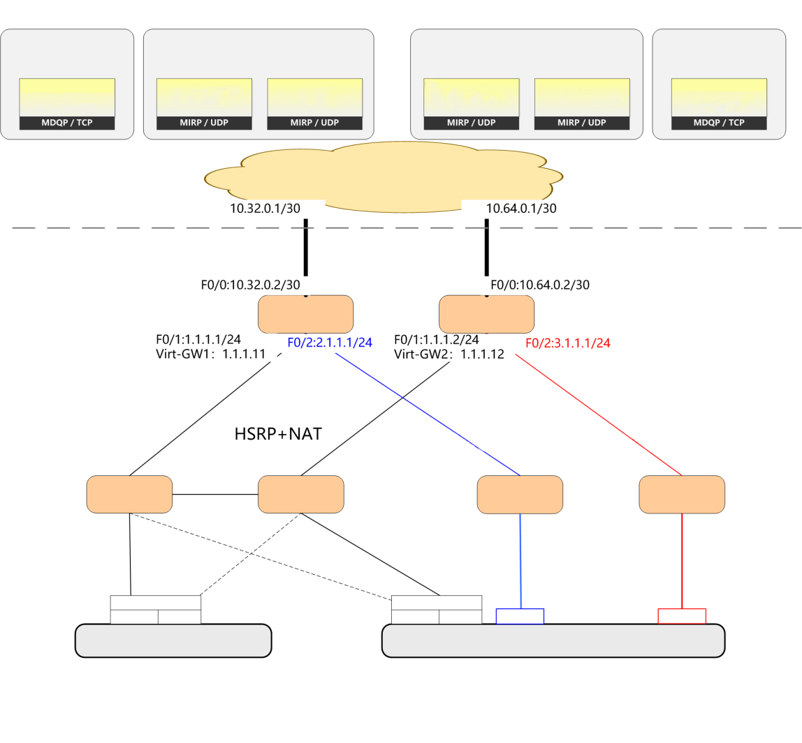
PD-DC
ZJ-DC
Market Data Query
Market Data Incremental
Market Data Incremental
Market Data Query
Source: 192.168.11.0/24
Source: 192.168.32.0/24
Group: 239.1[0-255] [0-255]
User Login/ Logout
Market Data Incremental Query
Market Data Snapshot Query
Source: 192.168.64.0/24
Group: 239.2[0-255] [0-255]
Channel A
Channel B
Source: 192.168.48.0/24
Group: 239.3[0-255] [0-255]
Source: 192.168.80.0/24
Group: 239.4[0-255] [0-255]
Channel A
Channel B
Source: 192.168.12.0/24
User Login/ Logout
Market Data Incremental Query
Market Data Snapshot Query
INE Access Platform
PD-DC Line
(To Channel A)
ZJ-DC Line
(To Channel B)
INE
Member-end
Route-A
Route-B
Unicast Network Channel
Multicast Network Channel
Channel A
Channel B
Unicast Switch-A
VLAN C
Unicast Switch-B
VLAN C
Multicast Switch-A
VLAN A
Multicast Switch-B
VLAN B
Primary-Secondary Mode
NIC C
NIC D
Primary-Secondary Mode
NIC C
NIC D
NIC A
NIC B
Existing Order Server
Order/ Market Data Server
NIC C+D:1.1.1.102/24 (Unicast)
Gateway: 1.1.1.12 or 1.1.1.11
NIC A 2.1.1.102/24
Gateway: 2.1.1.1

NIC B 3.1.1.102/24
Gateway: 3.1.1.1
NIC C+D:1.1.1.102/24 (Unicast)
Gateway: 1.1.1.11 or 1.1.1.12
Figure 2 Topology Diagram for Access Reference Model I - Channel Separation Model
As shown in Figure 2, the “channel separation” model bring less impact on members’ networks. A new multicast network is built to carry the multicast market data without impact existing network architectures. Existing unicast network continues offering unicast services. This model is recommended for members that originally apply the HSRP+NAT mode, Details as follows:
- Leased lines sharing: Members can reuse the two existing leased lines that connected to PD-DC and ZJ-DC to receive multicast market data; there is no need to apply for new leased lines. INE’s Primary Center is set with two market data channels - Channel A and Channel B. The two channels push the same content. PD-DC network access channel pushes market data on channel A, while ZJ-DC network access channel pushes market data on channel B. The multicast market data will increase the bandwidth usage, so members are advised to assess bandwidth utilization beforehand.
- Build new multicast network: It is suggested to allocate an Ethernet interface from each of the two routers. The Ethernet interface would be used for the multicast network channels; Deploy two switch devices (multicast switches A and B) for Channel A and Channel B respectively. It is not advised to interconnect multicast switches A and B.
- There is no need to adjust unicast network; it can still be used for existing unicast services.
- Market data server: The server need with four NICs. Wherein, NIC A is connected to Multicast Switch A, and receives multicast market data from Channel A. NIC B is connected to Multicast Switch B, and receives multicast market data from Channel B. NIC C/D (redundancy as primary-secondary mode) are connected to unicast network to access market data query services.

Configuration Example I (SSM Mode)
- Router: (To ensure the reliable reception of market data, it is required to configure relevant parameters of the multicast market data in INE’s primary and secondary centers at the same time)
！ Enable multicast routing
ip multicast-routing
！ Define SSM address range; Must be configured!
ip pim ssm range 239.0.0.0/13
！ Enables multicast routing protocol on external interface
interface F0/0
ip pim sparse-mode
！ Enables multicast routing protocol and IGMP on internal interface
interface F0/2
ip pim sparse-mode
ip igmp version 3
！ Add static routes to multicast source for RPF detection in order to build a multicast distribution tree (for Router-A configuration only)
ip route 192.168.48.0/24 F0/0 10.32.0.1 name ZJ-FeedA
ip route 192.168.32.0/24 F0/0 10.32.0.1 name PD-FeedA
！ Add static routes to multicast source for RPF detection in order to build a multicast distribution tree (for Router-B configuration only)
ip route 192.168.80.0/24 F0/0 10.64.0.1 name ZJ-FeedB
ip route 192.168.64.0/24 F0/0 10.64.0.1 name PD-FeedB

- Switch:
! Enable IGMP snooping, forward multicast on demand to avoid floods
ip igmp snooping

- The host system and application and enable IGMP v3 and join in corresponding multicast group (S,G).

Configuration Example II (ASM Mode)
- Router (To ensure the reliable reception of market data, it is required to configure relevant parameters of the multicast market data for both INE’s primary and secondary centers) :
！ Enable multicast routing
ip multicast-routing
！ Enables multicast routing protocol on external interface
interface F0/0
ip pim sparse-mode
！ Enables multicast routing protocol and IGMP on internal interface
interface F0/2
ip pim sparse-mode
ip igmp version 2
！ Configure a static RP towards Channel A (for Router-A configuration only)
ip pim rp-address 192.168.32.250
！ Configure a static RP towards Channel A (for Router-B configuration only)
ip pim rp-address 192.168.64.250
—— The Exchange does not provide RP connectivity testing
！ Configure a multicast source of Channel A and a unicast static route of PR, and build a multicast tree (for Router-A configuration only)
ip route 192.168.48.0/24 F0/0 10.32.0.1 name ZJ-FeedA
ip route 192.168.32.0/24 F0/0 10.32.0.1 name PD-FeedA
！ Configure a multicast source of Channel A and a unicast static route of PR, and build a multicast tree (for Router-B configuration only)
ip route 192.168.80.0/24 F0/0 10.64.0.1 name ZJ-FeedB
ip route 192.168.64.0/24 F0/0 10.64.0.1 name PD-FeedB

- Switch:
！ Enable IGMP snooping, forward multicast on demand to avoid floods
ip igmp snooping

- The host system and application and enable IGMP v2 and join in corresponding multicast group.

Access Reference Model II (Channel Sharing)
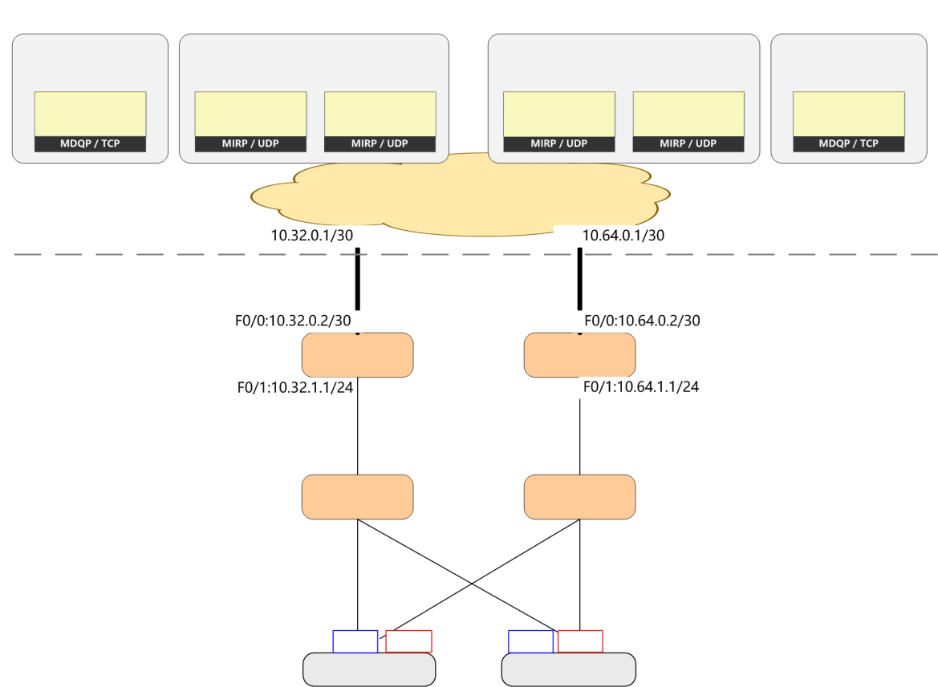
PD-DC
ZJ-DC
Market Data Query
Market Data Incremental
Market Data Incremental
Market Data Query
Source: 192.168.11.0/24
Source: 192.168.32.0/24
Group: 239.1[0-255] [0-255]
User Login/ Logout
Market Data Incremental Query
Market Data Snapshot Query
Source: 192.168.64.0/24
Group: 239.2[0-255] [0-255]
Channel A
Channel B
Source: 192.168.48.0/24
Group: 239.3[0-255] [0-255]
Source: 192.168.80.0/24
Group: 239.4[0-255] [0-255]
Channel A
Channel B
Source: 192.168.12.0/24
User Login/ Logout
Market Data Incremental Query
Market Data Snapshot Query
INE Access Platform
PD-DC Line
(To Channel A)
ZJ-DC Line
(To Channel B)
INE
Member-end
Route-A
Route-B
Unicast/ Multicast Channel Mergence
Channel A
Channel B
Switch-A
VLAN C
Switch-B
VLAN B
NIC A
NIC B
NIC B
NIC A
Offer/ Market Data Server-2
NIC A 10.32.1.102/24
Gateway: 10.32.1.1
NIC B 10.64.1.102/24
Gateway: 10.64.1.1
Offer/ Market Data Server-1
NIC A 10.32.1.101/24
Gateway: 10.32.1.1
NIC B: 10.64.1.101/24
Gateway: 10.64.1.1
Figure 3 Topology Diagram for Access Reference Model II - Channel Mergence Model
As shown in Figure 3, in the channel sharing model, there is no need to change existing network architecture; it is only necessary to add multicast related configurations. Existing network architecture provides both unicast and multicast services. For a member that originally applies a non-HSRP+NAT mode, this model is recommended. Details as follows:
- Leased lines sharing: Members can reuse the two existing leased lines that connected to PD-DC and ZJ-DC to receive multicast market data; there is no need to apply for new leased lines. INE’s Primary Center is set with two market data channels - Channel A and Channel B, which are connected to PD-DC and ZJ-DC respectively. The multicast market data will increase the bandwidth usage, so members are advised to assess bandwidth utilization beforehand.
- Network sharing: The two routers receive market data from Channel A and Channel B, respectively. The two switches forward market data from Channel A and Channel B. The TCP data generated by original unicast services is forwarded as usual.
- Market data server: The server shall be equipped with 2 NICs. NIC A and NIC B are connected to Channel A and Channel B respectively.

Configuration Example I (SSM Mode)
- Router: (To ensure the reliable reception of market data, it is required to configure relevant parameters of the multicast market data in INE’s primary and secondary centers at the same time)
！ Enable multicast routing
ip multicast-routing
！ Define SSM group address range; must be configured
ip pim ssm range 239.0.0.0/13
！ Enables multicast routing protocol on external interface
interface F0/0
ip pim sparse-mode
！ Enables multicast routing protocol and IGMP on internal interface
interface F0/1
ip pim sparse-mode
ip igmp version 3
！ Add static routes to multicast source for RPF detection in order to build a multicast distribution tree (for Router-A configuration only)
ip route 192.168.48.0/24 F0/0 10.32.0.1 name ZJ-FeedA
ip route 192.168.32.0/24 F0/0 10.32.0.1 name PD-FeedA
！ Add static routes to multicast source for RPF detection in order to build a multicast distribution tree (for Router-B configuration only)
ip route 192.168.80.0/24 F0/0 10.64.0.1 name ZJ-FeedB
ip route 192.168.64.0/24 F0/0 10.64.0.1 name PD-FeedB

- Switch:
! Enable IGMP snooping, forward multicast on demand to avoid floods
ip igmp snooping

- The host system and application and enable IGMP v3 and join in corresponding multicast group (S,G).

Configuration Example II (ASM Mode)
- Router: (To ensure the reliable reception of market data, it is required to configure relevant parameters for receiving the multicast market data in INE’s primary and secondary centers at the same time)
！ Enable multicast routing:
ip multicast-routing
！ Enables multicast routing protocol on external interface
interface F0/0
ip pim sparse-mode
！ Enables multicast routing protocol and IGMP on internal interface
interface F0/1
ip pim sparse-mode
ip igmp version 2
！ Configure a static RP towards Channel A (for Router-A configuration only)
ip pim rp-address 192.168.32.250
！ Configure a static RP towards Channel A (for Router-B configuration only)
ip pim rp-address 192.168.64.250
—— The Exchange does not provide RP connectivity testing
！ Configure a multicast source of Channel A and a unicast static route of PR, and build a multicast tree (for Router-A configuration only)
ip route 192.168.48.0/24 F0/0 10.32.0.1 name ZJ-FeedA
ip route 192.168.32.0/24 F0/0 10.32.0.1 name PD-FeedA
！ Configure a multicast source of Channel A and a unicast static route of PR, and build a multicast tree (for Router-B configuration only)
ip route 192.168.80.0/24 F0/0 10.64.0.1 name ZJ-FeedB
ip route 192.168.64.0/24 F0/0 10.64.0.1 name PD-FeedB

- Switch:
! Enable IGMP snooping, forward multicast on demand to avoid floods
ip igmp snooping

- The host system and application and enable IGMP v2 and join in corresponding multicast group

Application Procedure and Processing

Application Procedure
The detailed application procedure is as follows:
- Step 1: Application for Access to SMDP2.0
- The member shall first read and understand the specifications in Access Guide, then fill out and send the Application Form for Access to INE Market Data Platform (SMDP2.0) to INE.
- INE checks if the member is qualified for accessing the Platform. If unqualified, INE will notify the member, and may require extra application materials. If qualified, INE will approve the application, and send multicast market data to the member on both Channel A and B. All members may visit the INE website to obtain related market data parameters.
- Step 2: SMDP2.0 Reception Debug
- SMDP2.0 Reception Debug: Upon proper deployment of the reception environment by the member, INE will send the multicast market data on Channel A/B as requested by the member in its application.
- SMDP2.0 Access Redundancy Testing: The member is required to perform redundancy test on multicast market data reception, then fill out and send the Redundancy Testing Report for Access to INE Market Data Platform (SMDP2.0) to INE.
- Approve access: After above testing report is approved by INE. The member is allowed to receive market data from SMDP2.0 as normal.

Application Processing
- Application Portal
Members can visit INE’s member service system to download the application form, and email it to INE upon completion. Data information vendors may apply to the Information Management Department of INE.
- Contacts
Please visit the INE website to obtain contacts. Website: www.ine.com.cn.

Troubleshooting Guide

Basic Policy
The multicast troubleshooting can be divided into two parts: data flow and protocol signal:
- Data flow: data transmission from the multicast source, forwarding path "first hop device-intermediate device-last hop device", multicast data replication by last-hop device, and reception by member-end-server.
- Protocol signal: joining/leaving multicast group, and construction of a multicast distribution tree.

Basic Approaches
The examples provided in this chapter are for reference only. Members should check according to their own equipment and software. Cisco 3825 (version c3825-adventerprisek9-mz.150-1.M2.bin) is used in the examples.
Table 1: Check the Forwarding of Multicast Data Flow
Inspection Item | Inspection Method | Criterion
Whether multicast data is received from SHFE  (source inspection) | show interface | Check the count of multicast packets on the interface
 | show ip accounting | Check the forwarding count of a multicast stream
 | show ip traffic | Check statistics on traffic forwarding
Whether multicast data is forwarding normally  (channel inspection) | show ip mroute active | Check the packet rate
 | show ip mroute count | Check the forwarding and packet loss of multicast streams
Whether multicast data is received by host  (receiver inspection) | ifconfig | Check the count at NIC
 | netstat - tunlp | Check the snooping at the application port
 | Capture packets | Check the packets received by NIC

Table 2: Check the Status of Multicast Protocol
Inspection Item | Inspection Method | Criterion
Multicast Channel  First-hop/ Intermediary/ Last-hop Device | show ip multicast | Check whether the multicast function is enabled
 | show ip route | Check whether the unicast routing of source is configured correctly
 | show ip rpf <ip_addr> | Check whether the multicast RPF detection is correct
 | show ip pim neighbor | Detect neighbors of multicast routing (no neighbors would be created between SHFE and members; neighbors here refer to members' internal multicast domains)
 | show ip pim interface | Check whether the interface is enabled, and DR election
 | show ip mroute | Check the multicast routing table (whether IIF/OIF/RPF/Flag and other information is correct)
 | show ip igmp group | Check the information on terminal’s joining/ quitting groups
 | show ip igmp interface | Check IGMP version, timer and other information
 | show ip igmp snooping group | Check IGMP snooping, and the accuracy of router port/ host port
Receiver | IGMP version inspection | Make sure the host/ application system has adopted Version 3
 | Others
Note: If no irregularities are found in the above inspections, please further investigate at the application level.

Member Application Form
Application Form for Access to INE Market Data Platform (SMDP2.0)
Company Name
(stamp)
Member/ Data Information Vendor No. |  |  | Remote Seat Username
Access Information
Software Supplier and Version |  |  | Fax
Name of Technical Contact Person |  |  | Tel
Mobile |  |  | Email
Access Address
Leased Line Information | PD-DC Line No. |  |  | Operator |  | □Telecom □Unicom
 |  |  |  | Internal LAN |  | □
 |  |  |  | Rate
 | WAN IP |  |  | LAN IP
 | ZJ-DC Line No. |  |  | Operator |  | □Telecom □Unicom  □China Mobile
 |  |  |  | Rate
 | WAN IP |  |  | LAN IP
Multicast Mode | □PIM-SSM + IGMPv3 □PIM-ASM + IGMPv2
Topic of Multicast Market Data | (Please fill out the topics of multicast market data as needed. For details, refer to the parameters of the multicast market data topics released by INE.)
Remarks:
Instructions:
1) The traffic generated by overlay multicast will increase the bandwidth usage, so please assess bandwidth utilization beforehand;
2) Please fill out this form and email it, together with its stamped PDF scan, to INE;
3) For the convenience of archiving, please name the file as "Application Form for Access to INE Market Data Platform (SMDP2.0)+Member No.+Company Name in Short+Line No.”.
Redundancy Testing Report for Access to INE Market Data Platform (SMDP2.0)
Company Name
(stamp)
Member/ Data Information Vendor No. |  |  |  | Remote Seat Username
Access Address of
Member/ Data Information Vendor
Leased Line 1
Access Point |  |  | □PD-DC □ZJ-DC
Type |  |  |  | Operator Name
Line No. |  |  |  | Bandwidth
WAN Router Model |  |  |  | WAN Router Name
VAN Interface Address |  |  |  | Market Data Server IP
Leased Line 2
Access Point |  |  | □PD-DC □ZJ-DC
Type |  |  |  | Operator Name
Line No. |  |  |  | Bandwidth
WAN Router Model |  |  |  | WAN Router Name
VAN Interface Address |  |  |  | Market Data Server IP
Test Methods
1 | Check whether Channel A can receive market data normally |  |  | Result:
2 | Check whether Channel B can receive market data normally |  |  | Result:
3 | Enable Channel A/B at the same time, and then cut Channel A, check whether Channel B can receive market data normally |  |  | Result:
4 | Enable Channel A/B at the same time, and then cut Channel B, check whether Channel A can receive market data normally |  |  | Result:
5 | Check whether market data query services can operate normally |  |  | Result:
Remarks
Instructions: 1) Please fill out this form and email it, together with its stamped scan, to INE;
2) For the convenience of archiving, please name the file as "Redundancy Testing Report for Access to INE Market Data Platform (SMDP2.0)+Member/ Data Information Vendor No.+ Company Name in Short + Line No.”.

